Fourth Grade Sample Common Core Aligned Questions
http://www.p12.nysed.gov/assessment/common-core-sample-questions/math-grade-4.pdf
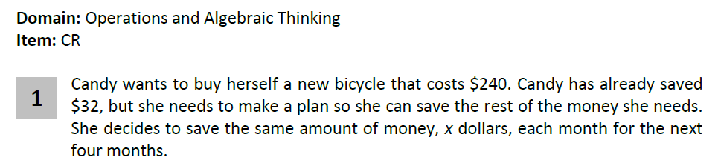
I think that this is an interesting question that is within the range of the operation expectations for 4th grade. What I disagree with is how Part A and Part B are arranged and the exemplary solution.

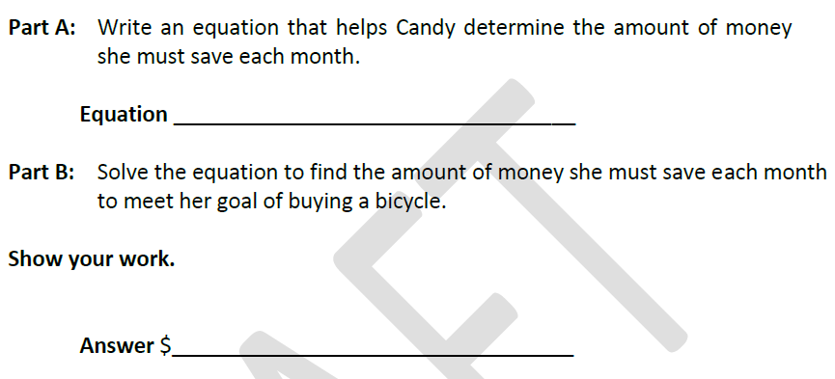

The standard this question is aligned to says
4.OA.3 Solve multistep word problems posed with whole numbers and having whole-number answers using the four operations, including problems in which remainders must be interpreted. Represent these problems using equations with a letter standing for the unknown quantity. Assess the reasonableness of answers using mental computation and estimation strategies including rounding.
The standard does not say that students need to solve multistep problems algebraically. You can represent a problem with an equation without using a formal algebraic solution to obtain an answer. I asked this question to Bill McCallum and he agreed
The question as currently structured would require a 4th grader to have mastered formal algebraic solutions which is not the expectation of the standards in 4th grade.
The way that I would encourage a 4th grader to attack this problem would be as follows:
$240

$32
Candy needs to save $52 a month.

32 + 4x = 208
had + saved = total cost of the bike
Needs $208
(split into 4 equal pieces because she will
save the same amount for 4 months)
$$240$$
- 32
208
$200÷$ 4 = 50
8 $÷$ 4 = 2
208 $÷$ 4 = 52

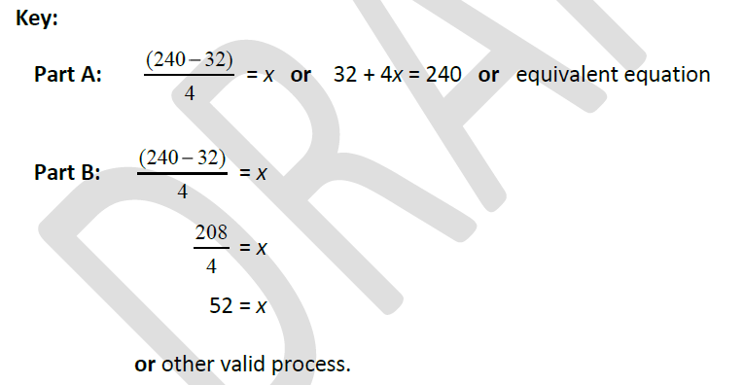

By supplying the line for the equation first, it reduces the likelihood that students would seek out another valid process.
The exemplary response contains math that hasn’t been covered in 4th grade.
For example:
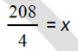 Using the fraction format to display a division problem doesn’t come into play until 5th grade.
5.NF.3 Interpret a fraction as division of the numerator by the denominator (a/b = a ÷ b). Solve word problems involving division of whole numbers leading to answers in the form of fractions or mixed numbers, e.g., by using visual fraction models or equations to represent the problem.
I have a similar concern with the solution to problem 2. The exemplary response for the second problem contains
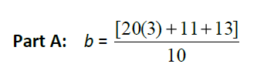
As far as I can see, the nested parentheses and brackets shows up for the first time in 5th grade so a 4th grader wouldn’t have the ability to create this type of solution if a teacher was instructing them according to the common core standards.
5.OA1 Use parentheses, brackets, or braces in numerical expressions, and evaluate expressions with these symbols

