Exploring Tape Diagrams

Tape diagrams are models designed to help students demonstrate their mathematical reasoning and gain a deeper understanding of the content. Our next step is to dig a little deeper.

Each table will be given an envelope with 5 problems that require students to use modeling. Each group member will select a single question from the envelope.

Step #1: Model and solve your question

Step #2: Share your thinking with a partner

Step #3: Imagining you are in front of a classroom of students. Model your thinking to guide your
“students” through the Read, Draw, Write (RDW) process. Each group member will assume
the role of teacher for their selected question.

Step #4: After each group member is done assuming the role of teacher, place the questions in order
of grade level.

RDW or Read, Draw, Write (a Number Sentence and a Statement)

Mathematicians and teachers suggest a simple process applicable to all grades:

- Read

- Draw and Label

- Write a number sentence (equation)

4) Write a word sentence (statement)

The more students participate in reasoning through problems with a systematic approach, the more they internalize those behaviors and thought processes.

- What do I see?

- Can I draw something?

- What conclusions can I make from my drawing?

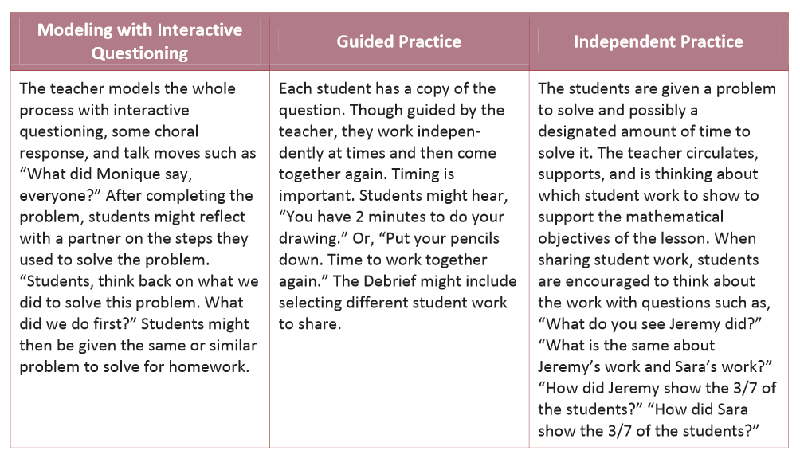

Extension:

Using the problem you selected from the envelope, construct an additional question that could be answered using your model.

