1st grade Math Module 2
Application Problems/Picture Cards/Templates
Southwestern Elementary School

Lesson 1
John, Emma, and Alice each had 10 raisins. John ate 3 raisins, Emma ate 4 raisins, and Alice ate 5 raisins.
How many raisins do they each have now?
Write a number bond and a number sentence for each.

Lesson 2
Lisa was reading a book. She read 6 pages the first night, 5 pages the next night, and 4 pages the following night.

How many pages did she read?

Make a drawing to show your thinking.

Write a statement to go with your work.

Extension: If she read a total of 20 pages by the fifth night, how many pages could she have read on the fourth night and the fifth night?

Lesson 3
Tom’s mother gave him 4 pennies. His father gave him 9 pennies. His sister gave him enough pennies that he now had a total of 14.
How many pennies did his sister give him? Use a drawing, number sentence, and a statement.

Extension: How many more would he need to have 19 pennies?

Lesson 4

Michael plants 9 flowers in the morning. He then plants 4 flowers in the afternoon.
How many flowers did he plant?
Make a drawing, number bond, and a statement.

Lesson 5
There are 9 red birds and 6 blue birds in a tree. How many birds are in the tree? Use a ten-frame drawing and a number sentence.
Write a number bond to match the story and a number bond to show the matching 10+ fact.
Write a statement.

Lesson 6
There are 6 children on the swings and 9 children playing tag. How many children are playing on the playground?
Make ten to solve.
Create a drawing, number bond, and number sentence along with your statement.

Lesson 7

Stacy made 6 drawings. Matthew made 2 drawings. Tim made 4 drawings.

How many drawings did they make altogether?

Use a drawing, a number sentence, and a statement to match the story.

Friendly Fact Go Around: Make it Equal

9 + 1 = 10 + ☐ 9 + 3 = 10 + ☐ 9 + 5 = 10 + ☐

9 + 4 = 10 + ☐ 9 + 7 = 10 + ☐ 9 + 6 = 10 + ☐

3 + 9 = 10 + ☐ 2 + 9 = 10 + ☐ 8 + 9 = 10 + ☐

5 + 9 = 10 + ☐ 4 + 9 = 10 + ☐ 9 + 9 = 10 + ☐

9 + 4 = ☐ + 10 9 + 6 = ☐ + 10 9 + 5 = ☐ + 10

9 + 2 = ☐ + 10 9 + 7 = ☐ + 10 9 + 9 = ☐ + 10

9 + ☐ = 10 + 5 9 + ☐ = 10 + 7 9 + ☐ = 10 + 8

9 + ☐ = 10 + 3 9 + ☐ = 10 + 4 9 + ☐ = 10 + 6

Lesson 8

A tree lost 8 leaves one day and 4 leaves the next.
How many leaves did the tree lose at the end of the two days?

Use a number bond, a number sentence, and a statement to match the story.

Extension: On the third day, the tree lost 6 leaves. How many leaves did it lose by the end of the third day?

Lesson 9

A squirrel found 8 nuts in the morning, 5 nuts in the afternoon, and 2 nuts in the evening.
How many nuts did the squirrel collect in all?

Extension: The next day, the squirrel found 3 more nuts in the morning, 1 more in the afternoon, and 1 more in the evening. How many did he collect over the two days?

Lesson 10

There were 4 boots by the classroom door, 8 boots in the hallway, and 6 boots by the teacher’s desk.
How many boots were there altogether?
Extension: How many pairs of boots were there in all?

Lesson 11

Nicholas bought 9 green apples and 7 red apples. Sofia bought 10 red apples and 6 green apples. Sofia thinks she has more apples than Nicholas. Is she right?

Choose a strategy you have learned to show your work.

Also, write number sentences to show how many apples Nicholas and Sofia each have.

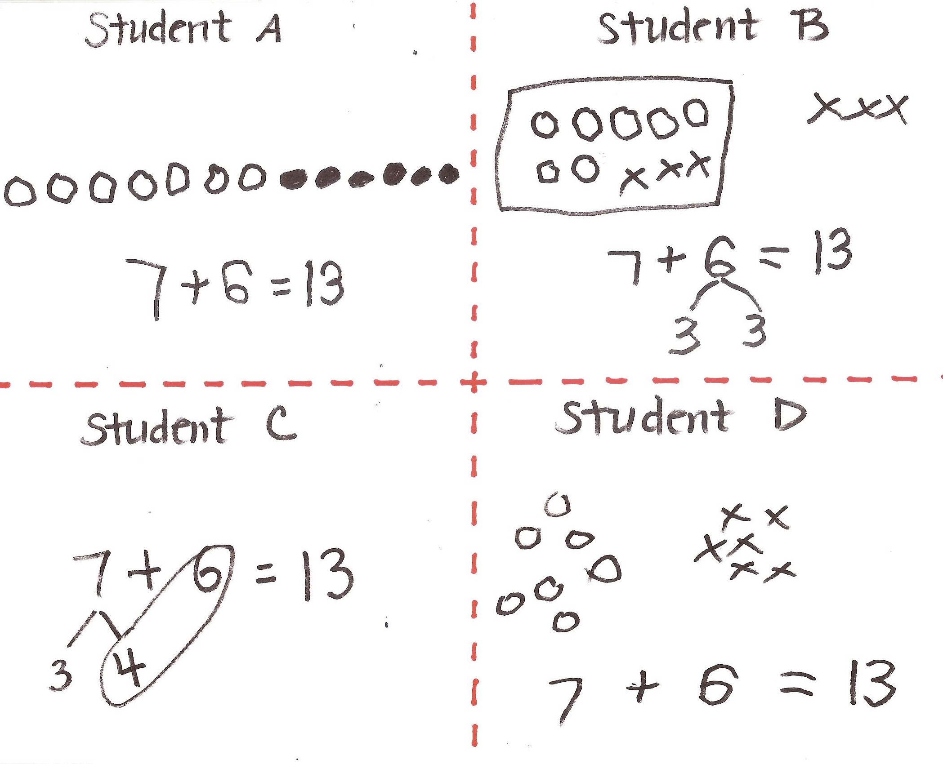

Lesson 12

Claudia bought 8 red apples and 9 green apples.

How many apples does Claudia have altogether?

Make a math drawing, number sentence, and statement to show your thinking.

Extension: Claudia ate 3 red apples and her friend ate 4 green apples. How many apples does Claudia have now?

Lesson 13

Ten snowflakes fell on Sam’s mitten and 6 fell on his coat. Nine of the snowflakes on Sam’s mitten melted.

How many snowflakes are left?

Write a subtraction sentence to show how many snowflakes are left.

Lesson 14

Sarah has 6 blue beads in her bag and 4 green beads in her pocket. She gives away the 6 blue beads and 3 green beads.

How many beads does she have left?

Lesson 15

Julian has 7 markers. His mother gives him 8 more. He loses 9 markers.

How many does he have left?

Lesson 16

There were 16 coats on the rack. Nine students took their coats to go outside.

How many coats were still on the rack?

Extension: If 4 more students take their coat to go outside, how many coats will still be hanging?

Lesson 17

Gisella had 13 markers in her bag. Eight markers fell out of the bag.

How many markers does Gisella have now?

Lesson 18

Juliana rolls 8 cars down a ramp.
If she started with 15 cars at the top of the ramp, how many cars does Juliana still have at the top of the ramp?

Lesson 19

Carla, Jose, and Yannis each have 8 cherries. They all get more cherries to put in their bowls. Now Carla has 12 cherries, Jose has 14 cherries, and Yannis has 16 cherries.

How many more cherries did each child put in his or her bowl?

Write a number sentence for each answer.

Lesson 20

Imran has 8 crayons in his pencil box and 7 crayons in his desk.

How many crayons does Imran have in total?

Lesson 21

There are 16 reading mats in the classroom. If 9 reading mats are being used, how many reading mats are still available?

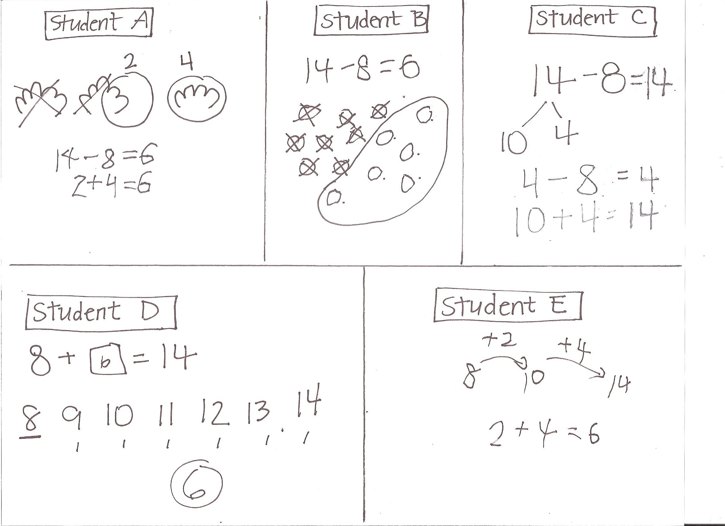

Lesson 22

No Application Problem in Lesson 22

Lesson 23

In the morning, there were 8 leaves on the floor under the ficus tree. During the day, more leaves fell on the floor. Now there are 13 leaves on the floor.

How many leaves fell during the day?

Lesson 24

Yesterday, I saw 11 birds on a branch. Then, 3 birds joined them on the branch.

How many birds were on the branch then?

Lesson 25

Micah had 16 trucks and lost 9 of them. Charles had 1 truck and received 6 more trucks from his mother.

Who has more trucks, Micah or Charles?

Lesson 26

Ruben has 18 toy cars. His car carrier holds 10 toy cars. If Ruben’s carrier is full, how many cars are in the carrier and how many cars are outside of the carrier?

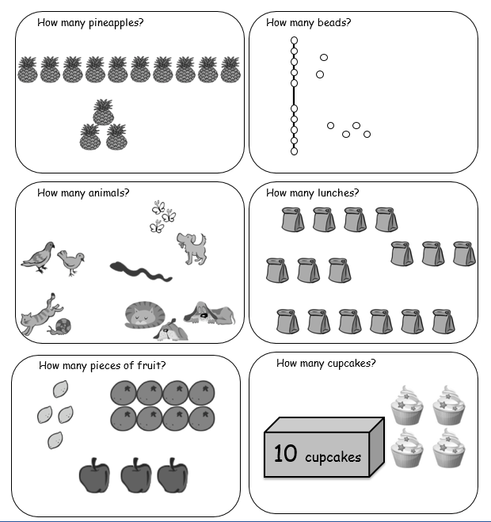

Lesson 27

Ruben was putting away his 14 toy cars. He filled his car carrier and had 4 cars left that could not fit.

How many cars fit in his car carrier?

Lesson 28

Ruben has 7 blue cars and 6 red cars. If Ruben puts all of the blue cars in his car carrier that carries 10 cars, how many red cars will fit in the carrier, and how many will be left out of the carrier?

Lesson 29

Hae Jung had 13 markers and she gave some to Lily. If Hae Jung then had 5 markers, how many markers did she give to Lily?

