Kindergarten Module 3 Fluency Progression
Lesson 1
Objective: Compare lengths using taller than and shorter than with aligned and non-aligned endpoints.
Fluency Practice (10 minutes)
- Tell the Hidden Number K.CC.2 (4 minutes)
- 5-Group Finger Counting K.CC.2 (2 minutes)
- Say Ten Push-Ups K.NBT.1 (4 minutes)
Tell the Hidden Number (4 minutes)
Materials: (S) Pennies, number path
Partner A closes her eyes. Partner B hides one of the numbers on the number path with a penny, and then tells Partner A to open her eyes. Partner A tells the hidden number. Partners switch roles and play again. Circulate and provide support to students who must count from 1 to determine the hidden number each time.
Variation: Cover two or three numbers with pennies.
Note: This activity will maintain students’ proficiency in number order, especially starting from a number other than 1. Challenge them by folding the number path to show short sequences (e.g., 4, 5, 6, 7), and have them hide one or two numbers.
5-Group Finger Counting (2 minutes)
T: Quick! Show me 5!
S: (Extend an open left hand to show 5 without having to count.)
T: Show me 1 more.
S: (Show an open left hand for 5 and the thumb of the right hand for 6.)
T: We can count from 5 like this: 5 (push out the left hand), 1 more (push out the thumb of the right hand) is… (push both the left hand and the thumb of the right hand) 6! Try it with me. Ready?
S: 5 (push out the left hand), 1 more (push out the thumb of the right hand) is… (push both the left hand and the thumb of the right hand) 6!
T: Stay there at 6. Now show me 1 more.
S: (Show an open left hand for 5 and the thumb and the index finger of the right hand for 7.)
T: How many fingers are you showing on your left hand?
S: 5.
T: And your right hand?
S: 2.
T: How many fingers are you showing in all?
S: 7.
T: So this time we’ll say 5 (push out the left hand), 2 more (push out the thumb and index finger of the right hand) is… (push out both the left hand and the thumb and index finger of the right hand) 7! Try it with me. Ready?
S: 5 (push out the left hand), 2 more (push out the thumb and index finger of the right hand) is… (push out both the left hand and the thumb and index finger of the right hand) 7!
Continue to 10 if students are ready, but no need to rush—this is a challenging counting activity. As students begin to note the pattern, steadily remove the scaffold until they can state the relationship to the 5-group without guidance. It would be better for students to achieve mastery to 7 then to mimic the teacher to 10.
Note: This activity helps to solidify students’ understanding of numbers to 10 in relationship to the five, which will be useful in upcoming lessons.
Say Ten Push-Ups (4 minutes)
T: You’ve gotten so good at counting to ten, it’s time to start counting higher! Next is ten 1. Repeat please.
S: Ten 1.
Ten 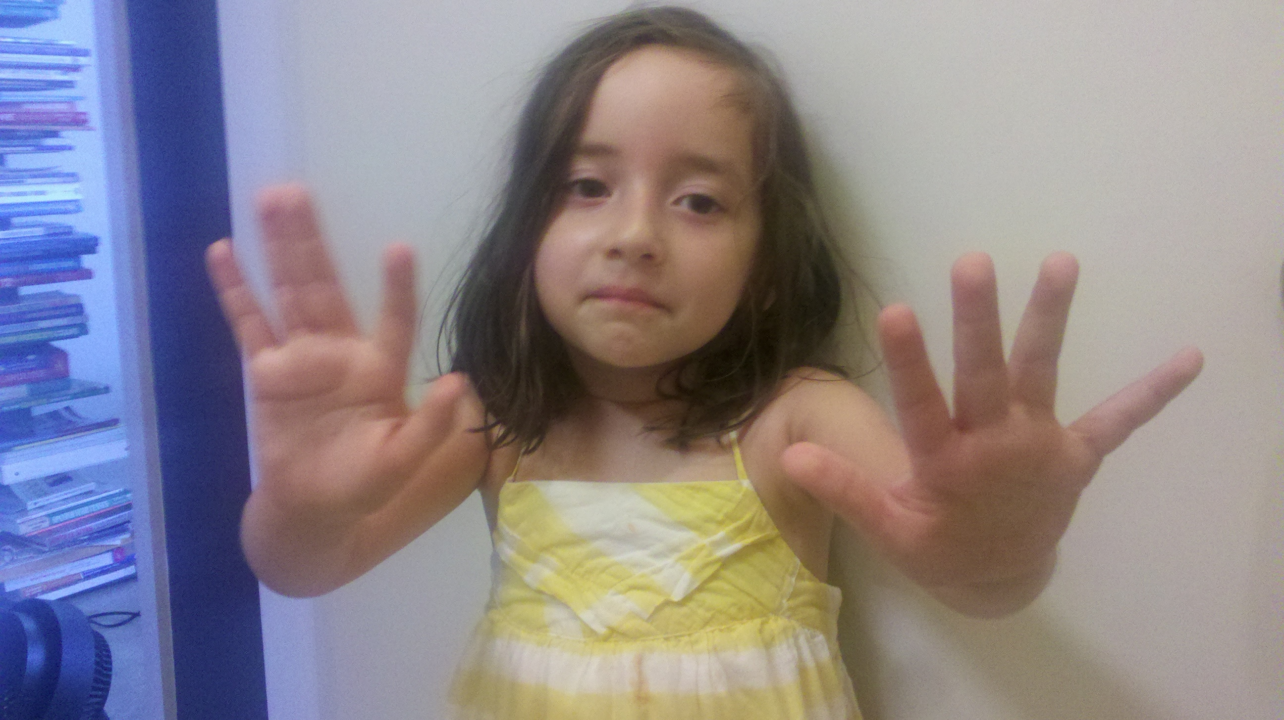
and 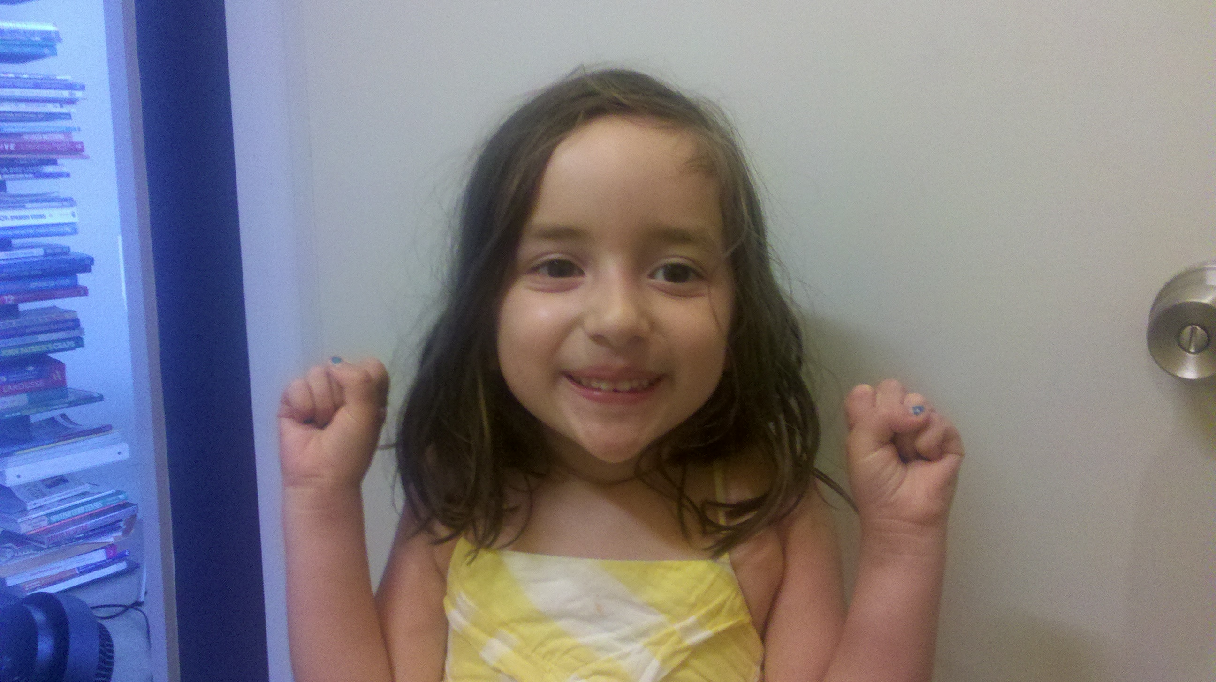
4 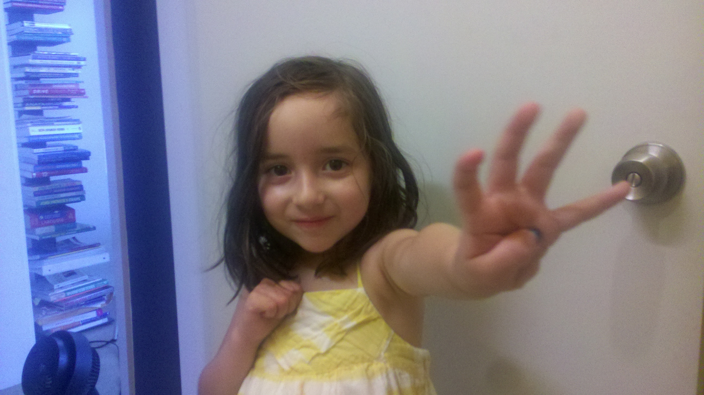

T: We can show it on our hands like this: ten (push out both hands, palms out, as if doing a push-up exercise in the air, then pause with closed fists close to body), 1 (push out the right hand pinky finger). It’s your turn, ready?
S: Ten (push out both hands as if doing a push-up exercise in the air) and (closed fists, close to body), 1 (push out the left hand pinky finger).
T: Very good. Next is ten (push out both hands as if doing a push-up exercise in the air) and (closed fists, close to body), 2 (push out the right hand pinky and ring fingers). It’s your turn, ready?
S: Ten (push out both hands as if doing a push-up exercise in the air) and (closed fists, close to body), 2 (push out the left hand pinky and ring fingers).
T: Ten (push out both hands as if doing a push-up exercise in the air) and (closed fists, close to body), 3 (push out the right hand pinky, ring, and middle fingers). It’s your turn, ready?
Continue a few more times, or until students can count and show the number on their hands fluently from ten to ten 3.
Note: This activity extends students’ understanding of numbers to 10 in anticipation of working with teen numbers. Some students may already know how to say the numbers the conventional way. Do not discourage them from making that connection, but perhaps encourage them to say the number conventionally in their mind so as to not confuse others.

Lesson 2
Objective: Compare length measurements with string.
Fluency Practice (10 minutes)
- Show Me Taller/Shorter K.MD.1 (3 minutes)
- Say Ten Push-Ups K.NBT.1 (3 minutes)
- Make It Equal K.CC.6 (4 minutes)
Show Me Taller/Shorter (3 minutes)
T: Let’s use our hands to show taller and shorter. For taller, we’ll do this (hold one hand above head and the other at waist level, indicating height). Show me taller.
S: (Show the hand gesture for taller.)
T: To show shorter, we’ll do this (hold hands closer than before, indicating a shorter height).
S: (Show the gesture for shorter.)
T: Let’s practice. Show me taller.
S: (Show the hand gesture for taller.)
T: Show me shorter.
S: (Show the gesture for shorter.)
Mix it up and quicken the pace to see that students understand the meaning of the vocabulary.
T: Look at my marker (hold a marker upright) and look at my crayon. Is the crayon shorter or taller?
T: Show me the gesture for taller, if you think the crayon is taller. Show me the gesture for shorter, if you think the crayon is shorter.
S: Student demonstrates either shorter or taller gestures.
Use a few more items for demonstration (book, pencil) for shorter, taller.
Note: This activity recalls the previous lesson’s work with height, connecting to today’s work with length.

Say Ten Push-Ups (3 minutes)
Conduct activity as described in GK–M3–Lesson 1, but now continue to ten 5.
Note: This activity extends students’ understanding of numbers to 10 in anticipation of working with teen numbers.
Make It Equal (4 minutes)
Materials: (S) Bags of beans, laminated paper or foam work mat, dice
- Teacher introduces the term equal as meaning the same number.
- Both partners roll dice, and put the same number of beans as dots shown on the dice.
- Partner A has to make her beans equal to her partner’s by taking off or putting on more beans.
- Partner B counts to verify.
- Switch roles and play again.
Note: Students develop a visual sense of comparison in this activity, preparing them to compare length of objects in this lesson.

Lesson 3
Objective: Make series of longer than and shorter than comparisons.
Fluency Practice (10 minutes)
- Say Ten Push-Ups K.NBT.1 (3 minutes)
- Hidden Numbers K.OA.3 (4 minutes)
- Make It Equal K.CC.6 (3 minutes)
Say Ten Push-Ups (3 minutes)
Conduct activity as outlined in GK–M3–Lesson 1, but now continue to ten 5, encouraging students to predict what comes next in the pattern.
Note: This activity extends students’ understanding of numbers to 10 in anticipation of working with teen numbers.
Hidden Numbers (5 as the Whole) (4 minutes)
Materials: (S) Hidden Numbers mat (template) inserted into personal white boards
T: Touch and count the fish on your mat. Raise your hand when you know how many (wait for all hands to go up, and then give the signal). Ready?
S: 10.
T: Put X’s on 5 of the fish. We’re not going to count those fish right now. Pretend they swam away!
S: (Cross out 5 fish.)
T: Circle a group of 4 from the fish who didn’t swim away.
T: How many fish are left?
S: 1.
T: Let’s circle that 1. How many did you circle all together?
S: 5.
T: Erase your boards. Put X’s on 5 of the fish again to show they swam away. How many fish did not swim away?
S: 5.
T: Now this time circle a group of 2. Circle another 2.
S: (Circle two groups of 2.)
T: How many fish have you circled so far?
T: Circle 1 more. Now how many are circled?
T: Erase your boards. Put X’s on 5 of the fish again. How many fish can we see?
T: This time circle a group of 3.
T: Circle a group of 2.
T: How many are in the larger group?
S: 3.
T: How many are in the smaller group?
S: 2.
T: How many did you circle all together?
S: 5.
Continue this procedure looking for hidden numbers within a group of 6. Pause occasionally to allow students to explain efficient ways of locating the groups.
Note: Finding embedded numbers anticipates the work of GK–Module 4 by developing part–whole thinking.
Make It Equal (3 minutes)
Conduct activity as outlined in GK–M3–Lesson 2, but now have students line up their beans (up to 10 beans) in horizontal rows or vertical columns.
Note: Students experience comparison visually, a skill crucial to the work of this module.

Lesson 4
Objective: Compare the length of linking cube sticks to a 5-stick.

Fluency Practice (10 minutes)
- Show Me Longer/Shorter K.MD.1 (3 minutes)
- Show Me Fingers the Say Ten Way K.NBT.1 (4 minutes)
- 5-Group Finger Counting K.CC.2 (3 minutes)
Show Me Longer/Shorter (3 minutes)
Conduct activity as described in GK–M3–Lesson 2, but with longer and shorter, so students extend their hands from side to side to indicate length.
Note: This activity was selected to review vocabulary with a kinesthetic component.
Show Me Fingers the Say Ten Way (4 minutes)
T: You’re getting very good at counting on your fingers the Say Ten way! Show me ten 1.
S: Ten (push out both hands as if doing a push-up exercise in the air) and (closed fists, close to body), 1 (push out the left hand pinky finger).
T: Show me ten 2.
S: Ten (push out both hands as if doing a push-up exercise in the air) and (closed fists, close to body), 2 (push out the left hand pinky and ring fingers).
Continue in a predictable pattern, then randomly.

5-Group Finger Counting (3 minutes)
Conduct activity as described in GK–M3–Lesson 1.
Note: This activity helps to solidify students’ understanding of numbers to 10 in relationship to the five, which will be useful in upcoming lessons.

Lesson 5
Objective: Determine which linking cube stick is taller than or shorter than the other.

Fluency Practice (10 minutes)
- Show Me Longer/Shorter K.MD.1 (2 minutes)
- 5-Group Hands K.CC.2 (4 minutes)
- 5-Groups on the Dot Path K.CC.2 (4 minutes)
Show Me Longer/Shorter (2 minutes)
Conduct activity as described in GK–M3–Lesson 2, but with longer and shorter, so students extend their hands from side to side to indicate length.
Note: This activity was selected to review vocabulary with a kinesthetic component.
5-Group Hands (4 minutes)
Conduct activity as described in GK–M2–Lesson 1, but this time showing the 5-group cards in the vertical orientation. Accordingly, students should put their hands side by side to represent the number.
Note: This maintenance activity develops flexibility in seeing the 5-groups vertically or horizontally, and adds a kinesthetic component.
5-Groups on the Dot Path (4 minutes)
Materials: (S) Dot path placed inside of a personal white board
T: Touch and count the dots on your dot path.
S: 1, 2, 3, …10.
T: What do you notice about the dot path?
S: There are 10 dots. There are two different color dots. A color change at 5!

T: Yes. I’m going to ask you to circle a group of dots. Use the color change at 5 to count and circle them as fast as you can. Ready? Circle 5.
S: (Circle a group of 5 dots.)
T: How did you do that so fast?
S: I just circled all the light ones, and I knew it was 5.
T: Erase. Get ready for your next number. Circle 6.
S: (Circle a group of 6 dots.)
T: How did you count 6?
S: I counted all of the dots until I got to 6. I counted one more than 5.
If students are starting to count on, let them share their thinking with the class. Continue the process with numbers to 10. Deviate from a predictable pattern as students show mastery.
Note: This activity helps students gain flexibility in grouping 5 and starting to count on from 5 pictorially.

Lesson 6
Objective: Compare the length of linking cube sticks to various objects.

Fluency Practice (10 minutes)
- Show Me Taller/Shorter K.MD.1 (3 minutes)
- Counting the Say Ten Way with the Rekenrek K.NBT.1 (4 minutes)
- Hidden Numbers K.OA.3 (3 minutes)
Show Me Taller/Shorter (3 minutes)
Conduct activity as described in GK–M3–Lesson 2.
Counting the Say Ten Way with the Rekenrek (4 minutes)
Materials: (T) 20-bead Rekenrek
T: We can count with the Rekenrek the same way we do our push-ups (fluency activity in previous lessons). (Keep the screen on the right side of the Rekenrek to cover beads which are not being counted. Slide over all of the beads on the top row.) How many do you see?
S: 10.
T: Here’s 1 more (slide over 1 bead on the bottom row). That’s what ten 1 looks like on the Rekenrek. How many do you see?
S: Ten 1.
T: (Slide 1 more bead over on the bottom row.) How many do you see?
S: Ten 2.
T: (Slide 1 more bead over on the bottom row.) How many do you see?
S: Ten 3.
Continue counting forward and backward with the following suggested sequence: ten 1, ten 2, ten 1, ten 2, ten 3, ten 2, ten 3, ten 2, ten 1, etc.

Note: This activity is an extension of students’ previous work with the Rekenrek, and anticipates working with teen numbers.
Hidden Numbers (3 minutes)
Conduct activity as described in GK–M3–Lesson 3, but this time guide students to find hidden numbers within a group of 7.

Lesson 7
Objective: Compare objects using the same as.

Fluency Practice (10 minutes)
- Counting the Say Ten Way with the Rekenrek K.NBT.1 (3 minutes)
- Roll and Draw 5-Groups K.OA.3 (4 minutes)
- Green Light, Red Light K.CC.2 (3 minutes)
Counting the Say Ten Way with the Rekenrek (3 minutes)
Conduct activity as described in GK–M3–Lesson 6, but this time continue to ten 5.
Roll and Draw 5-Groups (4 minutes)
Materials: (S) Dice (with the 6 dot side covered), personal white boards
Roll the dice, count the dots, and then draw the number as a 5-group.
Note: Observe to see which students erase completely and begin each time from 1 rather than draw more or erase some to adjust to the new number. By drawing 5-groups, students see numbers in relationship to the five.
Green Light, Red Light (3 minutes)
Draw a green dot with a 1 underneath and a red dot with a 3 underneath on the board. Explain to students that they will start counting and stop counting on the number as indicated by the color code.
T: Look at your numbers (point to the number 1 written below the green dot, and 3 below the red dot), think, ready… green light!
S: 1, 2, 3.
T: Very good! (Erase numbers 1 and 3, and write the new numbers.) New numbers (green is 3, red is 1). Look, think, ready… green light!

S: 3, 2, 1.
At this point in the year, it may not be necessary to start at 1. Work within a range that is comfortable for the students, and build incrementally. Challenge them by frequently changing directions between counting up and counting down.
Lesson 8
Objective: Compare using heavier than and lighter than with classroom objects.
Fluency Practice (19 minutes)
- Make It Equal K.CC.6 (6 minutes)
- Counting the Say Ten Way with the Rekenrek K.NBT.1 (4 minutes)
- Beep Number K.CC.4a (4 minutes)
- Draw More or Cross Out to Make 5 K.OA.3 (5 minutes)
Make It Equal (6 minutes)
Materials: (S) Bags of beans, laminated paper or foam work mat, dice
1. Teacher introduces the term equal as meaning the same number.
2. Both partners roll dice, and then put that many beans on their mat.
3. Partner A has to make her beans equal to her partner’s by taking off or putting on more beans.
4. Partner B counts to verify.
5. Switch roles and play again.
Variation: Have students line up their beans (up to 10 beans) in horizontal or vertical rows.
Counting the Say Ten Way with the Rekenrek (4 minutes)
Conduct activity as outlined in GK–M3–Lesson 6, but now continue to 20 (ten 2) if students are ready.
Beep Number (4 minutes)
Conduct activity as outlined in GK–M1–Lesson 15, but with teen number sequences, counting the Say Ten way. Numbers after will be easier to determine than numbers before, and realize that crossing ten will prove difficult.
Here are some examples of sequences from simple to complex:
Ten 1, ten 2, beep
Ten 6, beep, ten 8
Beep, ten 4, ten 5
9, beep, ten 1
Variation: Extend the sequences to four numbers, for example, ten 1, ten 2, beep, ten 4.
Note: This activity extends students’ proficiency in number order and anticipates working with teen numbers.
Draw More or Cross Out to Make 5 (5 minutes)
Materials: (S) Fluency Problem Set
After giving clear instructions and completing the first few problems together, allow students time to work independently. Encourage them to do as many problems as they can within a given time frame.
Optional: Go over the answers, and direct students to energetically shout “Yes!” for each correct answer.

Lesson 9
Objective: Compare objects using heavier than, lighter than, and the same as with balance scales.
Fluency Practice (14 minutes)
- Hidden Numbers K.OA.3 (5 minutes)
- 5-Group Hands K.CC.2 (4 minutes)
- Roll and Draw 5-Groups K.OA.3 (5 minutes)
Hidden Numbers (5 minutes)
Conduct activity as described in GK–M3–Lesson 3, but this time guide students to find hidden numbers within a group of 8.
5-Group Hands (4 minutes)
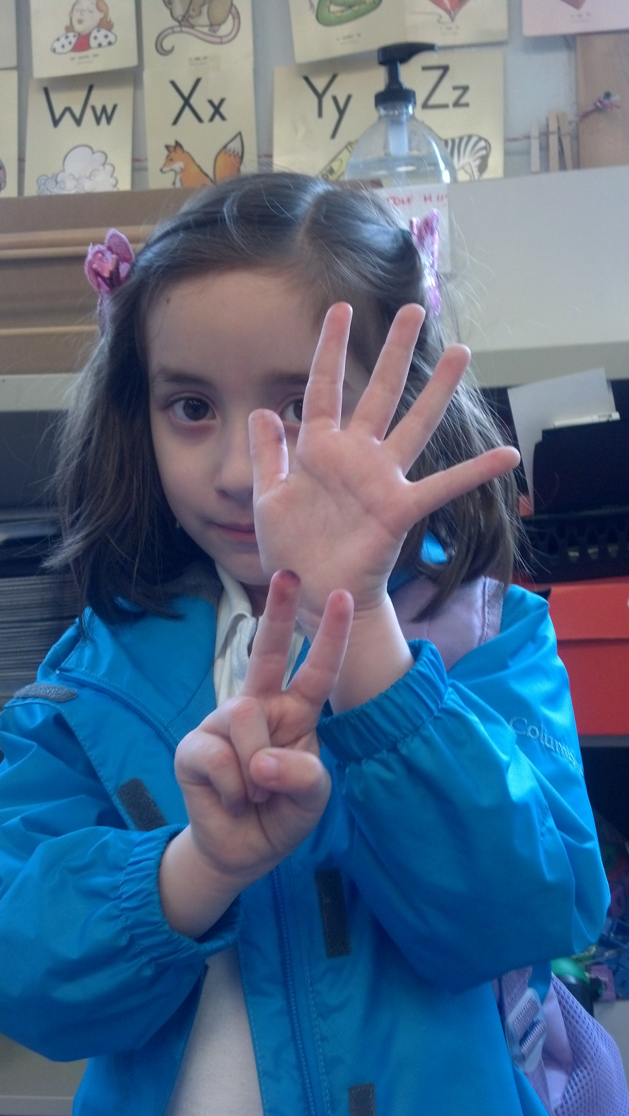
A student demonstrates
7 as 5 on top, and 2
on the bottom.
Materials: (T) Large 5-group cards (5–7)
T: (Show the 6 dot card.) Raise your hand when you know how many dots are on top. (Wait until all hands are raised, then signal.) Ready?
S: 5.
T: Bottom?
S: 1.
T: We can show this 5-group on our hands. 5 on top, 1 on the bottom, like this (demonstrate on hands, one above the other).
S: (Show 5 and 1 on hands, one above the other.)
T: Push your hands out as you count on from 5, like this. 5 (extend the top hand forward), 6 (extend the bottom hand forward). Try it with me.
S: 5 (extend the top hand forward), 6 (extend the bottom hand forward).
Continue with 5, 6, 7, steadily decreasing guidance from the teacher, until students can show the 5-groups on their hands with ease.
Note: This maintenance activity develops flexibility in seeing the 5-groups vertically or horizontally, and adds a kinesthetic component.
Roll and Draw 5-Groups (5 minutes)
Conduct activity as outlined in GK–M3–Lesson 7.
Note: Observe to see which students erase completely and begin each time from one rather than draw more or erase some to adjust to the new number. By drawing 5-groups, students see numbers as having length in relationship to the five.
Lesson 10
Objective: Compare the weight of an object to a set of unit weights on a balance scale.
Fluency Practice (11 minutes)
- Green Light, Red Light K.CC.2 (3 minutes)
- Make It Equal K.CC.6 (4 minutes)
- Double 5-Groups K.CC.2 (4 minutes)
Green Light, Red Light (3 minutes)
Conduct activity as described in GK–M3–Lesson 7, gradually building up to teen numbers counting the Say Ten way. Listen carefully for hesitation or errors, and repeat and break down certain sequences as needed.
Make It Equal (4 minutes)
Materials: (S) Bags of beans, foam or laminated paper work mat, dice
- Teacher introduces the term equal as meaning the same number.
- Both partners roll dice, and put that many beans on their mat.
- Partner A has to make their beans equal to their partner’s by taking off or putting on more beans.
- Partner B counts to verify.
- Switch roles and play again.
Double 5-Groups (4 minutes)
Materials: (T) Large 5-group cards
T: You’re getting so good at 5-groups now we’ll start using two cards! (Display the 10 dot card above the 1 dot card). This is the top card (gesture to indicate the entire 10 dot card, not just the top row
of dots). How many dots are on the top card? (Wait for all hands to go up, and then give the signal.) Ready?
S: 10!
T: This is the bottom card (gesture to indicate the entire 1 dot card). How many dots are on the bottom card? (Wait for all hands to go up, and then give the signal.) Ready?
S: 1!
T: Do you remember how many dots were on the top card?
S: Yes, 10.
T: Do we really need to go back and count them again?
S: No.
T: That’s right, we can take the shortcut! Count on from 10, like this, 10 (wave hand over the top card), ten 1 (crisply point to the dot on the bottom card). Try it.
S: 10, ten 1.
T: (Display the 10 dot card above the 2 dot card). How many dots are on the top card? (Wait for all hands to go up, and then give the signal.) Ready?
S: 10!
T: How many dots are on the bottom card? (Wait for all hands to go up, and then give the signal.) Ready?
S: 2!
T: Count on from 10.
S: 10, ten 1, ten 2.
Continue to ten 3.
Note: Introducing Say Ten counting now lays the foundation for later work with decomposing teen numbers.
Lesson 11
Objective: Observe conservation of weight on the balance scale.
Fluency Practice (13 minutes)
- Heavier or Lighter K.MD.1 (4 minutes)
- Double 5-Groups K.CC.2 (4 minutes)
- Hidden Numbers K.OA.3 (5 minutes)
Heavier or Lighter (4 minutes)
Materials: (T) Balance scale and assorted objects
T: Look at my objects (show a cotton ball and an orange, for example). I’m going to put them on the scale. Watch carefully to see how the scale moves. Raise your hand when you know which one is heavier. (Wait for all hands to go up, and then give the signal.) Ready?
S: The orange!
T: Yes, pretend you’re the scale! Show me the side that is heavier.
S: (Students pretend to hold the orange in one hand, and then quickly lower the hand to indicate weight.)
T: Now raise your hand when you know what is lighter. (Wait for all hands to go up, and then give the signal.) Ready?
S: The cotton ball!
T: Yes, now pretend you’re the scale! Show me the side that is lighter.
S: (Students pretend to hold the cotton ball in one hand and gradually lift it as if being pulled up by a balloon.)
Continue with a variety of objects, especially those that will produce unexpected results. Compare a large feather to a small rock so that students can see that size does not always correlate to weight.
Note: This activity prepares students for today’s lesson by reviewing vocabulary, isolating the attribute of weight, and incorporating a kinesthetic component to enhance conceptual understanding.
Double 5-Groups (4 minutes)
Conduct activity as outlined in GK–M3–Lesson 10, but now continue to ten 5.
Hidden Numbers (5 minutes)
Conduct activity as described in GK–M3–Lesson 3, but this time guide students to find hidden numbers within a group of 9.
Lesson 12
Objective: Compare the weight of an object with sets of different objects on a balance scale.
Fluency Practice (12 minutes)
- 5-Group Hands K.CC.2 (3 minutes)
- Roll and Draw 5-Groups K.OA.3 (5 minutes)
- Hidden Numbers on the Dot Path K.OA.3 (4 minutes)
5-Group Hands (3 minutes)
Conducted as described in GK–M3–Lesson 5, showing the 5-group cards in the vertical orientation. Accordingly, students should put their hands side by side to represent the number.
Note: This maintenance activity develops flexibility in seeing the 5-groups vertically or horizontally, and adds a kinesthetic component.
Roll and Draw 5-Groups (5 minutes)
Conducted as outlined in GK–M3–Lesson 7. Consider alternating between drawing the 5-groups vertically or horizontally.
Note: Observe to see which students erase completely and begin each time from one, rather than draw more or erase some to adjust to the new number. By drawing 5-groups, student see numbers as having length in relationship to the five.
Hidden Numbers on the Dot Path (4 minutes)
Materials: (S) Dot path inserted into personal white boards (see GK–M3–Lesson 15 for dot path)
T: Fold your dot path so that you can see only 6 dots. Place it inside your personal white board. How many dots can you see?
S: 6.
T: Circle 2 of them.
S: (Circle the first 2 dots.)
T: See how many twos you can circle on your dot path.
S: (Circle 3 sets of 2 dots).
T: How many dots are on the whole dot path?
S: 6.
T: How many twos did you find hiding within the 6?
S: 3.
Continue the process with finding groups of 3 within the 6. Guide students to find a group of 4 or 5, and then tell what number of dots remains.
Note: Finding embedded numbers anticipates the work of Module 4 by developing part–whole thinking.
Lesson 13
Objective: Compare volume using more than, less than, and the same as by pouring.
Fluency Practice (10 minutes)
- Dot Cards of 6 K.CC.2 (3 minutes)
- Building 1 More and 1 Less Towers K.CC.4c (4 minutes)
- Roll and Say 1 More, 1 Less K.CC.4c (3 minutes)
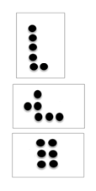
Dot Cards of 6 (3 minutes)
Materials: (T/S) Varied dot cards of 6
T: (Show card.) How many do you see?
S: 6.
T: How did you see them in two parts?
S: (Possible answers.) 5 up and 1 down, 2 down and 4 up, 3 up and 3 down.
Continue with other cards of 6. Distribute the cards to the students for partner sharing time. Have them pass on the card at a signal.
Note: This activity deepens students’ knowledge of embedded numbers and develops part–whole thinking, foundational to the work of the upcoming modules.
Building 1 More and 1 Less Towers (4 minutes)
Materials: (S) 10 linking cubes per student
Guide students through the process of building a tower while stating the pattern as 1 more. Maintain consistency in the language: 1. 1 more is 2. 2. 1 more is 3. 3. 1 more is 4. Continue to 10.
Disassemble the tower while stating the pattern as 1 less. Again, the language is crucial to students’ conceptual understanding: 10. 1 less is 9. 9. 1 less is 8. 8. 1 less is 7. Continue to 0.
Consider having students build the towers vertically as towers, but also horizontally as a train of cubes.
Note: In this activity, students connect increasing length and height to increasing numerical value.
Roll and Say 1 More, 1 Less (3 minutes)
Materials: (S) Pair of dice per student with the 6 dot side covered with a sticker
Roll the dice and count the dots. Make 1 more, and 1 less statements using consistent language. For example, if the student rolls a 4, they would say: 4. 1 more is 5. 4. 1 less is 3.
Note: This exercise prepares students for today’s lesson by moving flexibly between terms more and less.
Lesson 14
Objective: Explore conservation of volume by pouring.
Fluency Practice (11 minutes)
- Say Ten Push-Ups K.NBT.1 (3 minutes)
- Hidden Numbers (10 as the Whole) K.OA.3 (5 minutes)
- Double 5-Groups K.CC.2 (3 minutes)
Say Ten Push-Ups (3 minutes)
Conduct as outlined in GK–M3–Lesson 1. Continue to 20 (2 ten, or 10 and 10).
Hidden Numbers (10 as the Whole) (5 minutes)
Conduct as described in GK–M3–Lesson 3, except students will not need to cross out any of the fish. Guide them to find twos, threes, fours, and fives within the larger group of 10.
Double 5-Groups (3 minutes)
Conduct as described in GK–M3–Lesson 10, but now continue to 20 (2 ten, or 10 and 10).
Lesson 15
Objective: Compare using the same as with units.
Fluency Practice (12 minutes)
- Dot Cards of 7 K.CC.5, K.CC.2 (4 minutes)
- Make It Equal K.CC.6 (3 minutes)
- Building 1 More and 1 Less Towers K.CC.4c (5 minutes)
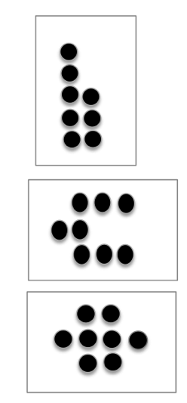
Dot Cards of 7 (4 minutes)
Materials: (T/S) Varied dot cards of 7
T: (Show 7 dots.) How many do you see? (Give students time to count.)
S: 7.
T: How can you see 7 in two parts?
S: (Come up to the card) 5 here and 2 here. I see 3 here and 4 here.
Continue with other cards of 7. Distribute the cards to the students for partner sharing time. Have them pass on the card at a signal.
Note: This activity deepens students’ knowledge of embedded numbers and develops part–whole thinking, crucial to the work of the upcoming modules.
Make It Equal (3 minutes)
Materials: (S) Bags of beans, foam or laminated paper work mat, dice with 6 side covered
1. Teacher introduces the term equal as meaning the same number.
2. Both partners roll dice, and put that many beans on their mat.
3. Partner A has to make their beans equal to their partner’s by taking off or putting on more beans.
4. Partner B counts to verify.
5. Switch roles and play again.
Note: Students experience comparison visually, a skill foundational to the work of this module.
Building 1 More and 1 Less Towers (5 minutes)
Conduct as described in GK–M3–Lesson 13, but now challenge students to stop at a certain number and then change directions so that they state the pattern of 1 more or 1 less starting from numbers other than 1 or 10.
T: Build up your tower while saying “1 more.” Stop when you get to 5.
S: 1. 1 more is 2. 2. 1 more is 3. 3. 1 more is 4. 4. 1 more is 5.
T: Stop! Now take it apart while saying 1 less. Stop when you get to 3.
S: 5. 1 less is 4. 4. 1 less is 3.
T: Stop!
Continue changing directions several more times. It might be helpful to use a stick of cubes that show a color change at 5 to facilitate identifying the number of cubes in the tower.
Note: In this activity, students connect increasing and decreasing height to increasing and decreasing numerical value.
Lesson 16
Objective: Make informal comparison of area.
Fluency Practice (13 minutes)
- Groups of Shapes K.G.2 (5 minutes)
- Show Me Bigger/Smaller K.MD.1 (3 minutes)
- Building Up to the Sprint Routine: Starting and Stopping at the Signal K.CC.3 (5 minutes)
Groups of Shapes (5 minutes)
Materials: (T) Signs with pictures of shapes to indicate where to form each group (S) Paper cutouts of triangles, rectangles, squares, hexagons, and circles (variety of sizes, include exemplars, non-examples, and variants)
T: Choose a shape, and then meet me at the rug.
T: Look at your shape. Raise your hand if you know the name of your shape. When I give the signal, whisper the name of your shape to yourself. Ready?
T: Look around the room. Do you see signs with pictures of shapes?
S: Yes.
T: Do you see your shape?
S: Yes.
T: When I start the music, I want you to calmly walk to the sign that has the same shape as yours.
T: When I point to your group, say the name of your shape. (Point to the group of triangles.)
S: Triangles!
Continue identifying the remaining groups, then call students back to the rug to trade for a new shape. Circulate to see which students struggle with this task, and support them by having them identify the attributes of their shape and comparing it to the shapes pictured on the signs.
Note: This activity prepares students for the current lesson by providing a quick review of shapes.

Show Me Bigger/Smaller (3 minutes)
Conduct similarly to the Show Me Taller/Shorter activity in GK─M3─Lesson 2, but have students position hands close together as if holding a tennis ball to indicate smaller and hands farther apart as if holding a basketball to indicate bigger.
Note: This activity prepares students for the current lesson by making visual and kinesthetic connections to size comparison.
Building Up to the Sprint Routine: Starting and Stopping at the Signal (5 minutes)
Materials: (S) Lined writing paper
T: When I say “go” we are going to practice writing numbers 1–10 quickly but carefully, like this (demonstrate). When you hear the bell ring, you must stop and hold up your pencil, even if you are not finished. What do you do when you hear the bell?
S: Stop and hold up your pencil.
T: Good. Remember, it’s ok if you don’t finish. Ready? Go!
S: (Write numbers 1─10.)
T: (Before students get to 10, ring the bell.) Pencils up, up, up!
S: (Hold pencils up.)
T: Wow! You really followed the directions! Let’s practice again. Ready? Go!
Continue several more times, praising students for following directions, rather than completing the task.
Note: Although the task is simple, this activity conditions students to stop working even when they have not finished, and develops the self-regulation that is necessary for participating in math Sprints. Teaching the Sprint routine in stages may be time-consuming, but the investment is well worth it. Students will begin their first Sprint in GK─M3─Lesson 21.
Lesson 17
Objective: Compare to find if there is enough.

Fluency Practice (11 minutes)
- Dot Cards of 8 K.CC.5, K.CC.2 (4 minutes)
- Show Me Bigger/Smaller K.MD.1 (3 minutes)
- Matching Fingertips One to One K.CC.6 (4 minutes)
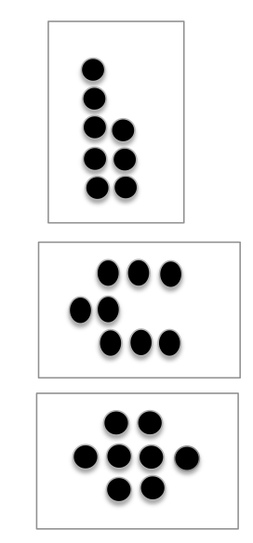
Dot Cards of 8 (4 minutes)
Materials: (T/S) Varied dot cards of 8 (examples at right)
T: (Show a card with 8 dots.) How many dots do you count? Wait for the signal to tell me.
S: 8.
T: How can you see them in two parts?
S: (Come up to the card.) I saw 4 here and 4 here. I saw 5 here and and 3 here. I saw 6 here and 2 here.
Repeat with other cards. Pass out the cards for students to work independently.
Note: This activity deepens students’ knowledge of embedded numbers and develops part–whole thinking, foundational to the work of upcoming modules.
Show Me Bigger/Smaller (3 minutes)
Conduct like the Show Me Taller/Shorter activity in GK─M3─Lesson 2, but have students position hands close together as if holding a tennis ball to indicate smaller and hands further apart as if holding a basketball to indicate bigger.
Note: This activity prepares students for the current lesson by making visual and kinesthetic connections to size comparison.
Matching Fingertips One to One (4 minutes)
Materials: (S) Dice
1. Partner A rolls a die and shows as many fingers as dots on the rolled die.
2. Partner B shows the same number of fingers.
3. Both partners touch fingertips, carefully matching one to one.
Note: This exercise relates to the concept of enough and anticipates drawing lines to match one to one pictorially in upcoming lessons.

Lesson 18
Objective: Compare using more than and the same as.

Fluency Practice (12 minutes)
- Finger Number Pairs K.CC.4a (4 minutes)
- Matching Fingertips One to One K.CC.6 (4 minutes)
- Matching Circles and Squares K.CC.6 (4 minutes)
Finger Number Pairs (4 minutes)
T: You’ve gotten very good at showing fingers the Math way. I want to challenge you to think of other ways to show numbers on your fingers. Hint… you can use two hands! First, I’ll ask you to show me fingers the Math way. Then, I’ll ask you to show me the number another way. Ready? Show me 2!
S: (Hold up the pinky and ring fingers of the left hand.)
T: Now show me another way to make 2, using two hands.
S: (Show 1 finger on each hand.)
T: How we can be sure that we’re still showing 2?
S: Count the fingers on both hands.
Continue the process with other numbers. For numbers where more than one combination is possible, have students try each others’ combinations.
Note: This activity ensures that students do not become overly reliant on counting the Math way and gives them yet another method of breaking apart numbers, essential to the work of the next module.

Matching Fingertips One to One (4 minutes)
Conduct as described in GK─M3─Lesson 17, but now invite students to show fingers a variety of ways and verify that it is still the same number of fingers.
Note: This exercise allows students to demonstrate the concepts of enough and same as and anticipates drawing lines to match one to one for comparison in upcoming lessons.
Matching Circles and Squares (4 minutes)
Materials: (S) Dice, personal white boards
1. Partner A rolls a die and draws the number of circles that corresponds to the number of dots on the rolled die.
2. Partner B draws that same number of squares.
3. Partner A draws lines to match circles to squares while both partners say, “One circle, one square, one circle, one square….”
Note: Students gain experience with equal quantities and practice one-to-one matching in anticipation of comparison.

Lesson 19
Objective: Compare using fewer than and the same as.

Fluency Practice (12 minutes)
- Dot Cards of 9 K.CC.5, K.CC.2 (4 minutes)
- Building Up to the Sprint Routine: Starting and Stopping at the Signal K.CC.3 (5 minutes)
- Show Me 1 More, 1 Less K.CC.4c (3 minutes)

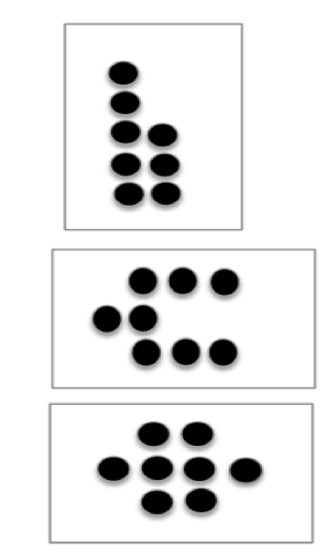
Dot Cards of 9 (4 minutes)
Materials: (T/S) Varied dot cards of 9 (examples at right)
T: (Show a card with 9 dots.) How many dots do you count? Wait for the signal to tell me.
S: 9.
T: How can you see them in two parts?
S: (Come up to the card.) I saw 5 here and 4 here. I saw 3 here and 6 here. I saw 2 here and 7 here.
Repeat with other cards. Pass out the cards for students to work independently.
Building Up to the Sprint Routine: Starting and Stopping at the Signal (5 minutes)
Conduct as described in GK─M3─Lesson 16, but this time, increase the level of difficulty by having students write the numbers counting down from 10 to 0.
Note: Although the task is simple, this activity conditions students to stop working even when they have not finished, and develops the self-regulation that which is necessary for participating in math Sprints. Teaching the Sprint routine in stages may be time-consuming, but the investment is well worth it.

Show Me 1 More, 1 Less (3 minutes)
T: Show me three fingers, the Math way.
S: (Hold up the left pinky, left ring finger, and the left middle finger.)
T: Now show me 1 more.
S: (Hold up the left pinky, left ring finger, the left middle finger, and the left index finger.)
T: How many fingers are you showing me now?
S: 4.
T: We can say it like this, “3. 1 more is 4.” Echo me, please.
S: 3. 1 more is 4.
T: New number. Show me 5.
S: (Show open left hand.)
T: Now show me 1 less.
S: (Hold up the left pinky, left ring finger, left middle finger, and the left index finger.)
T: How many fingers are you showing me now?
S: 4.
T: We can say it like this, “5. 1 less is 4.” Echo me, please.
S: 5. 1 less is 4.
Continue, and when they are ready, have students give 1 more and 1 less statements on their own.
Note: Students develop flexibility with the terms more and less, building upon the previous lesson, and preparing for the current lesson.

Lesson 20
Objective: Relate more and less to length.
Fluency Practice (13 minutes)
- Building Up to the Sprint Routine: Observing and Noticing K.CC.5 (8 minutes)
- Building 1 More and 1 Less Trains K.CC.4c (5 minutes)
Building Up to the Sprint Routine: Observing and Noticing (8 minutes)
Materials: (T) Sprint projected onto the board, framed portrait of the teacher at 5─6 years old
1. Tell students that they will watch you do a math race called a Sprint as if you were a student back in Kindergarten. Place the portrait on the desk where you will be working to remind students of your role. If possible, have an assistant play the role of the teacher delivering the Sprint.
2. At the start signal, turn the paper over and begin working. Start at the top left corner with the hearts and continue working down the hearts column. When you get to the bottom of the hearts column, start at the top of the stars column.
3. At the signal, stop and hold your pencil up, just as students have practiced in previous Sprint preparation exercises. Be careful to display a positive demeanor even though you have not finished the task. Maybe even pretend to wipe away sweat from the brow to emphasize working with intensity, and smile with satisfaction for having made such a strong effort! (Be sure to ask the assistant playing the role of teacher to limit the timeframe, or set a timer, so that you come very close to completing the Sprint, but do not quite finish.)
4. While going over the answers (now projected on the board), students circle correct answers in the air with their finger, along with the teacher, energetically shouting “Yes!” for each correct answer. The whole class counts the number of problems correct chorally and writes the number in the air as the teacher writes it at the top of the page.
5. Conclude the observation and role play, then gather the group at the rug to debrief the process. Here are suggested questions to guide the conversation:

- When did the teacher (playing the role of Kindergarten student) begin working on the problems?
- Which problems did the teacher do first—the hearts or the stars? (This question helps students realize that the Sprint is designed to be completed working down, not across the columns.)
- What did the teacher do when the timer sounded (or other stopping signal was made)? (Stopped working, even though not finished, and help up the pencil.)
- How did the teacher react at the end? (Emphasize that the goal is maximum effort and efficiency, not completion. Begin setting expectations for social and emotional behaviors during Sprints.)
Optional: Make a few intentional errors. Let students know to expect this beforehand. Tell them to be ready to explain what went wrong, being careful to avoid having students perceive the teacher as acting foolishly.
Note: Teaching the Sprint routine in stages may be time-consuming, but the investment is well worth it. Giving the students this opportunity to observe and reflect will increase motivation, enthusiasm, and success in this powerful fluency exercise. Students will complete their first Sprint in GK–M3–Lesson 21.
Building 1 More and 1 Less Trains (5 minutes)
Conduct as described in GK–M3–Lesson 15, but now have students build and disassemble the cubes horizontally, like a train.
Note: In this activity, students connect increasing and decreasing length to increasing and decreasing numerical value.

Lesson 21
Objective: Compare sets informally using more, less, and fewer.

Fluency Practice (13 minutes)
- My First Sprint K.CC.5 (8 minutes)
- Finger Number Pairs K.CC.4a (5 minutes)
My First Sprint (8 minutes)
Materials: (S) Sprint from GK─M3─Lesson 20
T: Today you will get to do a Math race called a Sprint. (Remind students of the previous day’s activity.) Take out your pencil and one crayon, any color.
T: (Distribute the Sprint papers facedown.) On your mark, get set, go!
T: (Ring the bell or give another signal for students to stop. Although it will not be necessary to time the students in this short practice Sprint, just be sure to give the stop signal before students finish, so as to not develop the expectation of finishing every time.) Pencils up!
T: Pencils down, crayons up! It’s time to check answers. What do you do if the answer is right?
S: Circle it.
T: What do you say?
S: Yes!
T: We’ll begin with the hearts. Ready? 1.
S: Yes!
T: 2.
S: Yes!
Continue checking the remaining answers, then have students count how many correct and write the number at the top. Keep the mood celebratory. Praise students for their strong effort, hard work, and for learning a new procedure. Note that only one Sprint is delivered this time, the two-part Sprint will be introduced in a future lesson.

Troubleshooting: If students work across, instead of down the columns make a green arrow down the left-hand side, and a red arrow along the right-hand side to indicate where to start and stop. If students have difficulty circling the answers quickly, give them a highlighter and allow them to “swipe” the correct answer.
Note: This activity allows students to become comfortable with the Sprint procedures as they work on this easy task with confidence.
Finger Number Pairs (5 minutes)
Conduct as outlined in GK–M3–Lesson 18, but this time invite students to explain why certain combinations cannot be shown on two hands. A student might say, “I can show 10 as 5 on one hand, and 5 on the other, but I can’t show 10 as 6 and 4.” Guide them to use some of their newly acquired vocabulary and be precise in explaining their thoughts.
Note: This activity ensures that students do not become overly reliant on counting the Math way and gives them yet another method of breaking apart numbers, essential to the work of the next module.

Lesson 22
Objective: Identify and create a set that has the same number of objects.

Fluency Practice (12 minutes)
- Make It Equal K.CC.6 (3 minutes)
- Roll and Draw 5-Groups K.OA.3 (5 minutes)
- 5-Group Fill-Up K.OA.4 (4 minutes)
Make It Equal (3 minutes)
Conduct as outlined in GK─M3─Lesson 15.
Note: Students experience comparison visually, a skill foundational to the work of this module.
Roll and Draw 5-Groups (5 minutes)
Conduct as outlined in GK─M3─Lesson 7. Consider alternating between drawing the 5-groups vertically or horizontally.
Note: Observe to see which students erase completely and begin each time from one, rather than draw more or erase some to adjust to the new number. By drawing 5-groups, students see numbers as having length in relationship to the five.
5-Group Fill-Up (4 minutes)
Materials: (S) Dice with 6 dot side covered, personal white boards
1. Partner A rolls the dice and draws a corresponding 5-group with O’s.

2. Partner B completes the ten by drawing X’s.
3. Both Partners engage in math talk: “ I have 7. You drew 3 more to make ten.”
Note: This activity gives students a head start in learning their partners to ten, anticipating the work of the next module.

Lesson 23
Objective: Reason to identify and make a set that has 1 more.

Fluency Practice (11 minutes)
- Show Me 1 More K.CC.4c (4 minutes)
- Roll and Say 1 More K.CC.4c (3 minutes)
- Finish My Sentence (1 More) K.CC.4c (4 minutes)
Show Me 1 More (4 minutes)
Conduct as described in GK─M3─Lesson 19, but focus exclusively on practicing 1 more. Maintain consistency in the language.
Note: Students continue to develop fluency in describing the pattern of 1 more, preparing them for the current lesson.
Roll and Say 1 More (3 minutes)
Conduct as described in GK─M3─Lesson 13, but focus exclusively on practicing 1 more. Maintain consistency in the language.
Note: A reiteration of the previous activity, but with a different representation (dice, in this case) develops flexibility, and ensures that students do not become too reliant on finger counting.
Finish My Sentence (1 More) (4 minutes)
T: Raise your hand when you can finish this sentence. 3, 1 more is… (Wait for all hands to go up, and then signal.)
S: 4!
T: 4, 1 more is… (Wait for all hands to go up, and then signal.)
S: 5!
Variation: After some whole group practice, have students do this activity with a partner.
Note: The previous fluency activities in this lesson build up to this more abstract version in preparation for today’s lesson.

Lesson 24
Objective: Reason to identify and make a set that has 1 less.

Fluency Practice (11 minutes)
- Show Me 1 Less K.CC.4c (4 minutes)
- Roll and Say 1 Less K.CC.4c (3 minutes)
- Finish My Sentence (1 Less) K.CC.4c (4 minutes)
Show Me 1 Less (4 minutes)
Conduct as described in GK─M3─Lesson 19, but instead focus exclusively on practicing 1 less. Maintain consistency in the language.
Note: Students continue to develop fluency in describing the pattern of 1 less, preparing them for the current lesson. This activity echoes the previous lesson’s work with 1 more, reinforcing the opposite nature of the concepts.
Roll and Say 1 Less (3 minutes)
Conduct as described in GK─M3─Lesson 13, but focus exclusively on practicing 1 less. Maintain consistency in the language.
Note: A reiteration of the previous activity, but with a different representation (dice, in this case) develops flexibility, and ensures that students do not become too reliant on finger counting.
Finish My Sentence (1 Less) (4 minutes)
T: Raise your hand when you can finish this sentence. 5. 1 less is… (Wait for all hands to go up, and then signal.)
S: 4!
T: 4. 1 less is… (Wait for all hands to go up, and then signal.)
S: 3!

Variation: After some whole group practice, have students do this activity with a partner.
Note: The previous fluency activities in this lesson build up to this more abstract version, in preparation for today’s lesson.

Lesson 25
Objective: Match and count to compare a number of objects. State which quantity is more.

Fluency Practice (12 minutes)
- Beat Your Score! K.CC.4b (12 minutes)
Beat Your Score! (12 minutes)
Materials: (S) 2 copies of the Sprint from GK─M3─Lesson 20 per student
Note: The purpose of this activity is to help students become accustomed to the full Sprint routine while completing a task involving relatively simple concepts (hence the reuse of a Sprint from GK─M3─Lesson 20). This will build confidence and enthusiasm for Sprints in the future.
T: It’s time for a Sprint! (Briefly recall previous Sprint preparation activities, and distribute Sprints facedown.) Take out your pencil and one crayon, any color.
T: On your mark, get set, go!
T: (Ring the bell or give another signal for students to stop. Although it will not be necessary to time the students in this short practice Sprint, be sure to give the stop signal before students finish, so as to not develop the expectation of finishing every time.) Pencils up!
T: Pencils down, crayons up!
T: It’s time to check answers. What do you do if the answer is right?
S: Circle it. (Circling correct answers instead of crossing out wrong ones avoids stigmatization.)
T: What do you say?
S: Yes!
T: We’ll begin with the hearts. Ready? 1.
S: Yes!
Proceed through the checking answers procedure as in GK─M3─Lesson 21.

T: Kindergarteners, do you ever wish you had more time? Another chance to do even better?
S: Yes.
T: Before we try again, let’s get our mind and body ready to work hard with an exercise. Stand up and push in your chairs. Let’s do jumping jacks while counting to 10. Ready?
S: 1, 2, 3, …10 (count while doing jumping jacks).
T: Hands on your hips, twist slowly, counting down from 10. Ready? (While students exercise, distribute the second set of Sprints, which is the same as the first.)
S: 10, 9, 8, …1 (count while twisting).
T: Have a seat. Pencils up. Do you remember the number you got the first time?
S: Yes.
T: See if you can beat your score! Race against yourself! On your mark, get set, go!
Students work on the Sprint for a second time. Perhaps give an additional three to five seconds, to help students beat their first score. Give the signal to stop, reiterating that is ok not to finish. Continue to emphasize that the goal is simply to do better than the first time. Proceed through the checking answers procedure with more enthusiasm than ever. Then, facilitate a comparison of Sprint A to Sprint B. Because students are still developing understanding of the concept of more, it may be necessary to circulate and facilitate the comparison, either visually, or numerically.
T: Stand up if you beat your score.
T: You worked so hard and I am so proud of you! Let’s celebrate (e.g., congratulate each other, give three pats on the back, shake hands, have a parade).
Variation: Allow students to finish, but provide an early-finisher activity to do on the back.

Lesson 26
Objective: Match and count to compare two sets of objects. State which quantity is less.

Fluency Practice (12 minutes)
- Matching Fingertips One to One K.CC.6 (4 minutes)
- Dot Cards of 6 K.CC.2 (4 minutes)
- Say Ten Push-Ups K.NBT.1 (4 minutes)
Matching Fingertips One to One (4 minutes)
Conduct as outlined in GK─M3─Lesson 17.
Note: This exercise allows students to practice one-to-one matching at the concrete level, preparing them to draw lines to match one to one pictorially in this lesson.
Dot Cards of Six (4 minutes)
Conduct as outlined in GK─M3─Lesson 13.
Note: Cycling back through 6, 7, 8, and 9 is essential in anticipating the work of the next module. While compositions of 5 have been well established at this point, numbers 6 through 9 will prove challenging.
Say Ten Push-Ups (4 minutes)
Conduct as outlined in GK─M3─Lesson 1. Continue to 20 (2 ten, or 10 and 10).
Note: This activity extends students’ understanding of numbers to 10 in anticipation of working with teen numbers.
Lesson 27
Objective: Strategize to compare two sets.

Fluency Practice (11 minutes)
- How Many Are Hiding? K.OA.4 (4 minutes)
- Hidden Numbers K.OA.3 (4 minutes)
- Show Me Taller/Shorter K.MD.1 (3 minutes)
How Many Are Hiding? (4 minutes)
T: How many fingers do you have on two hands?
S: 10.
T: Show me 9, piano style, like this. (Demonstrate fingers the Math way, palms down, flat on the table.)
T: How many fingers are hiding?
S: 1.
T: Let that finger come out now. 9 and 1 makes…
S: 10!
T: Now show me 8.
T: How many fingers are hiding?
S: 2.
T: Let those fingers come out now. 8 and 2 makes…
S: 10!
Work through all of the combinations of 10.
Note: Partners to ten is foundational with respect to development of ten as a unit. Starting early and practicing frequently will facilitate automaticity.

Hidden Numbers (4 minutes)
Conduct as described in GK─M3─Lesson 3, but this time guide students to find hidden numbers within a group of 6. Look for opportunities to compare sets within the larger group. Encourage students to use the newly acquired vocabulary of more, less, and same as. Hopefully, students will say, “6 is 4 and 2, but 4 is more than 2.” Or, “6 is 3 and 3. Hey, that’s the same number!”
Note: Finding embedded numbers anticipates the work of Module 4 by developing part–whole thinking.
Show Me Taller/Shorter (3 minutes)
Conduct as described in GK─M3─Lesson 2.
Note: Recalling this vocabulary prepares students for the Concept Development activities in this lesson.

Lesson 28
Objective: Visualize quantities to compare two numerals.

Fluency Practice (12 minutes)
- Sprint: Counting to 5 in Varied Configurations K.CC.4b (12 minutes)
Sprint: Counting to 5 in Varied Configurations (12 minutes)
Materials: (S) 2 copies of the Sprint per student
Follow the instructions for delivering a Sprint in GK─M3─Lesson 25. Giving the identical Sprint twice facilitates comparison from Sprint A to Sprint B, and allows students to see their growth. (Eventually, students will complete two Sprints that are similar, but not exactly the same.) Continue to emphasize the concept of beating your score. Praise students for their hard work, and for following directions in learning a new procedure.
T: It’s time for a Sprint! (Briefly recall previous Sprint preparation activities, and distribute Sprints facedown.) Take out your pencil and one crayon, any color.
T: On your mark, get set, go!
T: (Ring the bell or give another signal for students to stop. Although it will not be necessary to time the students in this short practice Sprint, just be sure to give the stop signal before students finish, so as to not develop the expectation of finishing every time.) Pencils up!
T: Pencils down, crayons up!
T: It’s time to check answers. What do you do if the answer is right?
S: Circle it. (Circling correct answers instead of crossing out wrong ones avoids stigmatization.)
T: What do you say?
S: Yes!
T: (Have students correct their work and incorporate a brief skip counting exercise including movement.)
T: See if you can beat your score! Race against yourself! On your mark, get set, go!
Students work on the Sprint for a second time. Perhaps give an additional three to five seconds, to help students beat their first score. Give the signal to stop, reiterating that is ok not to finish. Continue to emphasize that the goal is simply to do better than the first time. Proceed through the checking answers procedure with more enthusiasm than ever. Then, facilitate a comparison of Sprint A to Sprint B. Because students are still developing understanding of the concept of more, it may be necessary to circulate and facilitate the comparison, either visually, or numerically.
T: Stand up if you beat your score.
T: You worked so hard and I am so proud of you! Let’s celebrate (e.g., congratulate each other, give three pats on the back, shake hands, have a parade).
Variation: Allow students to finish, but provide an early-finisher activity to do on the back.
Note: Students get accustomed to the full Sprint routine while completing a task that is relatively simple conceptually. This will build confidence and enthusiasm for Sprints in the future.

Lesson 29
Objective: Observe cups of colored water of equal volume poured into a variety of container shapes.

Fluency Practice (12 minutes)
- Tower Flip K.OA.3 (5 minutes)
- 5-Group Fill-Up K.OA.4 (4 minutes)
- Full, Not Full, or Empty? K.MD.1 (3 minutes)
Tower Flip (5 minutes)
Materials: (S) 5 linking cubes
T: Touch and count your cubes.
S: 1, 2, 3, 4, 5.
T: How many cubes do you have?
S: 5.
T: Set them down on your table, like a tower.
T: Take 1 cube off the top of your tower and place it on the table, next to the tower. Do you still have 5 cubes?
S: Yes.
T: How many cubes are on the first tower?
S: 4.
T: On the other tower?
S: 1.
T: We can tell about it like this: 4 and 1 make 5. Echo me, please.
S: 4 and 1 make 5.
T: Good. Take another cube off the top of the first tower, and stick it on to the top of the other tower. Do you still have 5 cubes?
S: Yes.
T: How many cubes are on the first tower?
S: 3.
T: On the other tower?
S: 2.
T: Give me the and…make statement.
S: 3 and 2 make 5.
Continue transferring cubes from one tower to the other to work through all of the combinations of 5. Then, reverse the procedure and cycle back through the flipped combinations. Students should progress through the combinations in this order: 5 and 0, 4 and 1, 3 and 2, 2 and 3, 1 and 4, 0 and 5. Invite students to tell what they noticed about the towers as they did this exercise (one tower got taller while the other got shorter).
Note: At this point in the year, many students will have already mastered compositions of 3, 4, and 5. This activity seeks to build on their understanding of comparison in order to see the relationship between partner numbers, essential to the work of the next module.
5-Group Fill-Up (4 minutes)
Conduct as outlined in GK─M3─Lesson 22.
Note: This activity gives students a head start in learning how many a number needs to make ten, anticipating the work of the next module. This activity also links to the next fluency practice and the numerous ways that objects can be considered full.
Full, Not Full, or Empty? (3 minutes)
Materials: (T) Real objects filled with various amounts of liquids
T: Look at my water bottle. It is full because the water comes right to the top. I can’t possibly put any more water in here! Repeat after me, “It is full.”
S: It is full.
T: (Drink some of the water.) Now it is not full. Tell me.
S: It is not full.
T: (Show an empty water bottle.) This is my bottle from yesterday. There is no more water in it. Repeat after me, “It is empty.”

S: It is empty.
T: Now, I’ll show you some more things, and I want you to tell me if they are full, not full, or empty. (Show students a mug that is filled to the brim. Alternatively, to reduce spillage, the items could be displayed on a table or in the center of the rug with students seated on the edges of the rug so that they can see. Point to, rather than hold up, the focus object.) Raise your hand when you know what to say. (Wait for all hands to go up, then signal.) Ready?
S: Full!
T: Very good. (Hold up a vase of flowers with a little water in it.) Raise your hand when you know what to say. (Wait for all hands to go up, then signal.) Ready?
S: Not full!
T: Right. (Show students an empty bowl.) Ready?
S: Empty!
Note: A misconception students often have is that a container is full if it has any amount of liquid in it. This activity seeks to clarify the meaning of full in preparation for today’s work with capacity.

Lesson 30
Objective: Use balls of clay of equal weights to make sculptures.

Fluency Practice (12 minutes)
- Tower Flip K.OA.3 (4 minutes)
- Counting the Say Ten Way with the Rekenrek K.NBT.1 (3 minutes)
- Growing Apples to Ten K.OA.4 (5 minutes)
Tower Flip (4 minutes)
Conduct as outlined in GK─M3─Lesson 29, but this time have students lay the towers down on the table and refer to them as trains. While transferring cubes from one to the other, guide students to notice that as one train gets longer, the other gets shorter.
Note: Students see that the relationship between the quantities remains the same even though the orientation has changed from the previous iteration, from height to length.
Counting the Say Ten Way with the Rekenrek (3 minutes)
Conduct as described in GK─M3─Lesson 6, but continue to 2 ten, or ten and ten.
Growing Apples to Ten (5 minutes)
Materials: (S) Activity mat, 10 red beans, die with 6 dot side covered
1. Roll the die.
2. Put that many red beans on the apple tree, arranging them in 5-groups.
3. Count how many more are needed to make ten.
4. Say, “I have ____. I need _____ more to make ten.”
5. Do not remove the beans. Roll the die again. Count to see if there are enough spaces for that many beans. (If the number goes over 10, and there aren’t enough spaces, simply roll again to get a smaller number.) Then, place that many beans on the apple tree.
6. State the new amount and how many more it needs to make ten.
Continue until ten is made. Then, remove the beans and start again from 0 if time permits. This game can also be played with a partner. Or, a spinner can be used instead of a die.
Note: This activity gives students a head start in learning their partners to ten, anticipating the work of the next module.

Lesson 31
Objective: Use benchmarks to create and compare rectangles of different lengths to make a city.

Fluency Practice (12 minutes)
- Sprint: Rekenrek to 5 K.CC.5 (12 minutes)
Sprint: Rekenrek to 5 (12 minutes)
Materials: (S) 2 copies of the Sprint per student
Follow the instructions for delivering a Sprint in GK─M3─Lesson 25. Use the Lesson 31 Sprint for both rounds. Giving the identical Sprint twice facilitates comparison from Sprint A to Sprint B, and allows students to see their growth. (Eventually, students will complete two Sprints that are similar, but not exactly the same.) Continue to emphasize the concept of beating your score. Praise students for their hard work, and for following directions in learning a new procedure.
Note: Students grow more comfortable with the Sprint routine while completing a task that involving relatively simple concepts. This will continue to build confidence and enthusiasm for Sprints.

Lesson 32
Objective: Culminating task—describe measurable attributes of single objects.

Fluency Practice (8 minutes)
- Breaking Apart Dot Cards of 6 K.CC.2 (4 minutes)
- Mystery Attribute K.MD.2 (4 minutes)
Breaking Apart Dot Cards of 6 (4 minutes)
Materials: (S) Dot cards used in GK─M3─Lesson 13 inserted into personal white boards
1. Have students touch and count the dots.
2. Partner A circles a group of dots, then tells how many he circled.
3. Partner B tells how many are not circled, and gives an and…make statement (e.g., 4 and 2 make 6).
4. Partners erase, switch roles, and continue exploring compositions of 6.
Variation: Give two and…make statements when applicable (e.g., 4 and 2 is 6; 2 and 4 is 6.) Or, give two 6 is… statements when applicable (e.g., 6 is 5 and 1; 6 is 1 and 5.)
Note: Students decompose numbers pictorially in this activity, and develop part–whole thinking, essential to the work of the next module.
Mystery Attribute (4 minutes)
Materials: (T) Assorted classroom objects, simple balance scale
T: (Show students a pencil and crayon side by side, vertically, with endpoints aligned.) Listen carefully, and raise your hand when you know what word is missing: “The pencil is than the crayon.” (If students are unsure at first, offer two options—taller or heavier.) Ready?
S: Taller! Longer!

Repeat with pencil and crayon side by side, horizontally, with endpoints aligned. Repeat with objects on a balance scale. Continue with a variety of objects, having students identify the attribute by indicating taller or shorter, longer or shorter, and heavier or lighter.
Note: This activity challenges students by presenting multiple attributes, preparing them for the culminating task.

