**1st grade Math Module 1**

**Application Problems/Picture Cards/Templates**

**Southwestern Elementary School**

**Lesson 1**

Dora found 5 leaves that blew in through the window. Then she found 2 more leaves that blew in.

Draw a picture and use numbers to show how many leaves Dora found in all.

**Lesson 2**

Bella spilled some pencils on the carpet. Geno came over to help her pick them up. Geno found 5 pencils under the desk and Bella found 4 by the door.

How many pencils did they find together?

Draw a math picture, write a number sentence and number bond that tells about the story.

**Early Finishers:** Draw the 9 pencils in a different arrangement to show two parts.

**Concept Development Image to show 7**



**Lesson 3**

Alex had 9 marbles in his hand. He hid his hands behind his back and put some in one hand and some in the other.

How many marbles might be in each hand?

Use pictures or numbers to draw a number bond to show your idea.

**Lesson 4**

Our class had 4 pumpkins. On Monday, Marta brought 1 more pumpkin.

How many pumpkins did our class have?

On Tuesday, Beto brought 1 more pumpkin.

How many pumpkins did our class have on Tuesday?

Then on Wednesday, Shea brought 1 more pumpkin.

How many pumpkins did our class have on Wednesday?

Draw a picture and write a number sentence to show your thinking.

What do you notice about what happened each day?

**Early Finishers:** If this pattern continues, how many pumpkins will our class have on Friday?

**Lesson 4 Picture Card Template**



**Lesson 5**

Marcus had 6 pieces of candy. He decided to give some to his mother and keep some for himself.

Use pictures and numbers to show 2 ways that Marcus could have split up 6 pieces of his candy.

**Lesson 5 Picture Card Template**



**Lesson 6**

Tom has 4 red cars and 3 green cars. Dave has 5 red cars and 2 green cars. Dave thinks he has more cars than Tom has.

Is Dave right?

Draw a picture to show how you know.

Write a number bond to show each of the boys’ sets of cars.

**Lesson 6 Picture Card Template**

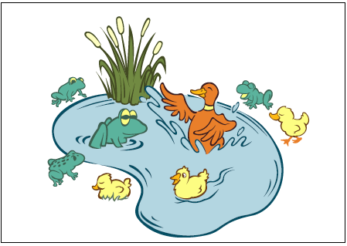

**Lesson 7**

Jenny has 8 flowers in a vase. The flowers come in two different colors.

Draw a picture to show what the vase of flowers might look like.

Write a number sentence and a number bond to match your picture.

**Lesson 7 Picture Card Template**



**Lesson 8**

Rayden received 9 stickers at school. He received 5 stickers in the morning.

How many stickers did he receive in the afternoon?

Draw a picture, a number bond, and a number sentence to show how you know.

**Lesson 8 Picture Card Template**



**Lesson 9**

Kiera was making a number bracelet with a total of 10 beads on it. She put on 3 red beads so far.

How many more beads does she need to add to the bracelet?

Explain your thinking in a picture and number sentence.

**Early finishers**: If Kiera wants to use 5 red beads and 5 yellow beads for her bracelet, how many red beads and how many yellow beads will she need to add?

**Lesson 10**

The class is collecting canned food to help those in need. The teacher brings in 3 cans to start the collection. On Monday, Becky brings in 2 cans. On Tuesday, Talia brings in 2 cans. On Wednesday, Brendan brings in 2 cans.

How many cans were there after each day?

Draw a picture to show your thinking. What do you notice about what happened each day?

**Early Finishers:** If this pattern continues, how many cans will our class have on Friday?

**Lesson 10 Picture Card Template**



**Lesson 10 Picture Card Template**



**Lesson 11**

There are 8 children in the afterschool cooking club.

How many boys and how many girls might be in the class?

Draw a picture and write a number sentence to explain your thinking.

**Early Finishers:** How many other combinations of boys and girls could be made? Write a number bond for each combination you can think of.

**Lesson 12**

Tanya has 7 books on her shelf. She borrowed some books from the library and now there are 9 books on her shelf.

How many books did she get at the library?

Explain your thinking in pictures, words, or with a number sentence.

Draw a box around the mystery number in your number sentence.

**Lesson 13**

Sammi had 6 bunnies. One of them had babies. Now she has 10 bunnies.

How many babies were born?

Draw a picture to show how you know.

Write a number bond and a number sentence to match your picture.

**Lesson 14**

Beth went apple picking. She picked 7 apples and put them in her basket. Two more apples fell out of the tree right into her basket!

How many apples does she have in her basket now?

Draw a math picture and write a number bond and number sentence to match the story.

**Lesson 14 Picture Card Template**

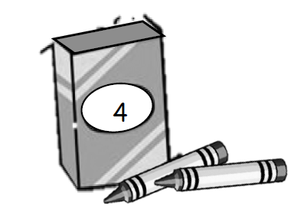

**Lesson 14 Picture Card Template**

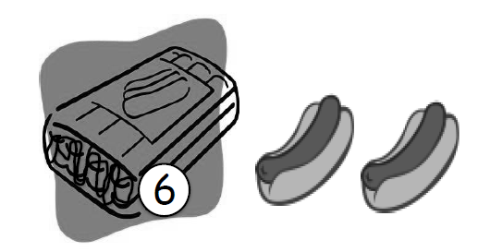

**Lesson 15**

Joshua and Rebecca were eating raisins. Joshua had 7 raisins and took 2 more from the box. Rebecca had 9 raisins and took 2 more from the box.

Who had a greater number of raisins, Joshua or Rebecca?

Draw math drawings, write number bonds or number sentences to show how you know.

**Lesson 16**

Finn knocked over some bowling pins and 7 were will standing.

How many did he knock over?

Use a simple math drawing to show what you did to solve.

Write a number sentence with a box to show the mystery or unknown number.

**Lesson 17**

There are 10 swings on the playground, 7 students are using the swings.

How many swings are empty?

Draw or write a number sentence to show your thinking.

Use a sentence at the end to answer today’s question: How many swings are empty?

**Lesson 18**

Dylan has 4 cats and 2 dogs at home. Laura has 1 dog and 5 fish at home. Laura says she and Dylan have an equal number of pets. Dylan thinks he has more pets than Laura. Who is right?

Draw a picture, write 2 number bonds, and use a number sentence to show if Dylan and Laura have an equal amount of pets.

**Lesson 19**

Dylan has 4 cats and 2 dogs at home. Sammy has 1 mama bunny and 6 baby bunnies at home.

Draw a number bond showing the total number of pets of each household.

Write a statement to tell if the two households have an equal number of pets.

**Lesson 20**

Laura had 5 fish. Her mother gave her 1 more. Laura’s brother Frank had 1 fish. Their mother gave Frank 5 more. Laura cried, “That’s not fair! He has more fish than I do!”

Use number bonds and a number sentence to show Laura the truth so she will calm down.

If you can, write a sentence with words that would help Laura understand.

**Lesson 21**

Jordan is holding a container with 3 pencils. His teacher gives him 4 more pencils for the container.

How many pencils will be in the container?

Write a number bond, number sentence, and statement to show the solution.

**Lesson 22**

May and Kay are twins. Whatever May has, Kay has it, too. May has 2 dolls.

How many dolls do May and Kay have together?

May has 3 stuffed animals. How many stuffed animals do they have together?

Write a number bond, number sentence, and statement to show your solution.

**Early finishers:** If all the dolls and all the stuffed animals were put together for an imaginary tea party, how many toys would there be?

Draw or write to explain your thinking.

**Lesson 23**

John has 3 stickers. Mark has 4 stickers. Anna has 5 stickers. They each get two more stickers.

How many do they each have now?

Write a number bond and number sentence for each student.

**Extension:** How many stickers do John, Mark, and Anna have together?

**Lesson 24**

The teacher told Henry to get 8 linker cubes. Henry took 4 blue cubes and 3 red cubes.

Does Henry have the correct amount of linker cubes?

Use pictures or words to explain your thinking.

**Lesson 25**

Taylor and her sister Reilly each got 4 books from the library. Then Reilly went back in and checked out another book.

How many books do Taylor and Reilly have together?

Draw and label a number bond to show the part of the books Taylor took our and the part that Reilly took out.

Write a statement to share your answer.

**Lesson 26**

There were 5 students in the cafeteria. Some more students came in late. Now there are 7 students in the cafeteria.

How many students came in late?

Write a number bond to match the story.

Write an addition sentence and a subtraction sentence to show two ways to solve the problem.

Draw a rectangle around the unknown number that you found.

**Lesson 27**

Marcus has 9 strawberries. Six of them are small. The rest are big.

How many strawberries are big?

Fill in your template. Circle the mystery, or unknown number, in your number sentences and write a statement to answer the question.

Materials: (S) Personal white board with the number path template

**Lesson 28**

8 ducks are swimming in the pond. 4 ducks fly away.

How many ducks are still swimming in the pond?

Write a number bond, number sentence, and statement.

Draw a number path to prove your answer.

**Lesson 29**

Lucas has 9 pencils for school. He lends 4 of them to his friends.

How many pencils does Lucas have left?

Box the solution in your number sentence, and include a statement to answer the question. Be sure to draw your simple shapes in a straight line.

**Lesson 30**

Freddie has 10 action figures in his pocket. 5 of them are “good guys.”

How many of his action figures are “bad guys?”

Box the solution in your number sentence, and include a statement to answer the question.

Make a math drawing. Circle the part that is good guys to show you have the correct number of bad guys.

**Lesson 31**

Shanika saw 5 pigeons on the roof. Some more pigeons flew on to the roof. She then counted 8 pigeons.

How many pigeons flew over?

Write a number bond and both addition and subtraction number sentences to match the story.

Box the solution in your number sentence, and include a statement to answer the question.

**Lesson 32**

There are 8 juice boxes in the cubbies. Some children drank their juice. Now there are only 5 juice boxes.

How many juice boxes were taken from the cubbies?

Make a number bond.

Write a subtraction sentence and a statement to match the story.

Make a box around the solution in your number sentence.

Make a math drawing to show how you know.

**Lesson 33**

9 children are playing outside. One child is on the swings and the rest are playing tag.

How many children are playing tag?

Write a number bond and number sentence.

Make a math drawing to show how you know.

**Lesson 34**

83 beads spill on the floor. A student picks up 1 bead.

How many beads are still on the floor?

Write a number bond, number sentence, and a statement to share your solution.

**Extension:** If a second child picks up 10 more beads, how many beads will remain on the floor?

Use number bonds to show how you know.

**Lesson 35**

The teacher spilled 18 beads on the floor today. A student picked up 17 of the beads.

How many beads are still left on the floor?

Write a number bond, number sentence, and a statement to share your solution.

**Extension:** If the 17 beads had been picked up by two students, how many beads might each student have picked up?

Make a number bond to show your solution.

**Lesson 36**

There are 10 beads on the floor. There is the same number of red beads as white beads. A student picks up the white beads.

How many beads are still on the floor?

Write a number bond, number sentence, and a statement to share your solution.

Make a math drawing to show how you know.

**Lesson 37**

There are 10 beads on the floor. A student picked up some of the beads and left some on the floor.

Write a number bond and a number sentence that would match this story.

**Extension:** What other number bonds and number sentences could match this story?

Try to list all of the possibilities.

**Lesson 38**

Jessie and Carl were comparing the beads they picked up. Jessie picked up 9 beads, 5 of them were red and the rest were white. Carl picked up 5 red beads and 4 white beads. Carl said they had the same amount of white beads.

Is Carl correct?

Draw and label your work to show your thinking.

**Lesson 39**

John has 10 pencils. Mark has 9 pencils. Anna has 8 pencils. They each lost two of their pencils.

How many do they each have now?

Write a number bond and number sentence for each student.