Progression of Strategies

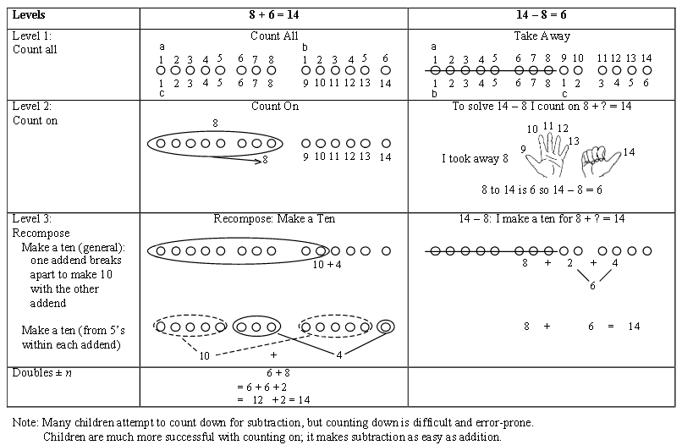

(Level 1, Level 2, and Level 3 Counting Strategies taken from the Counting and Cardinality; Operations and Algebraic Thinking Progressions Document)

Try It!

How could you solve 8 + 3 using the three levels of strategies?

How could you solve 14 – 5 using the three levels of strategies?

Kindergarten-

K.OA.3 Decompose numbers less than or equal to 10 into pairs in more than one way, e.g., by using objects or drawings, and record each decomposition by a drawing or equation (e.g., 5 = 2 + 3 and 5 = 4 + 1).

K.OA.4 For any number from 1 to 9, find the number that makes 10 when added to the given number, e.g., by using objects or drawings and record the answer with a drawing or equation.

K.NBT.1 Compose and decompose numbers from 11 to 19 into ten ones and some further ones, e.g., by using objects or drawings and record each composition or decomposition by a drawing or equation (such as 18 = 10 + 8); understand that these numbers are composed of ten ones and one, two three, four, five, six, seven, eight or nine ones.

K.OA.5 Fluently add and subtract within 5.

First Grade

1.OA.6 Add and subtract within 20, demonstrating fluency for addition and subtraction within 10. Use strategies such as
- counting on
- making ten (e.g., 8 + 6 = 8 + 2 + 4 = 10 + 4 = 14)
- decomposing a number leading to a ten (e.g., 13 – 4 = 13 – 3 – 1 = 10 – 1 = 9)
- using the relationship between addition and subtraction
(e.g., knowing that 8 + 4 = 12, one knows 12 – 8 = 4)
- creating equivalent but easier or known sums (e.g., adding 6 + 7 by creating the known equivalent 6 + 6 + 1 = 12 + 1 = 13).

Second Grade

2.OA.2 Fluently add and subtract within 20 using mental strategies. (See 1.OA.6 for a list of strategies.) By end of Grade 2, know from memory all sums of two one-digit numbers.

Use place value understanding and properties of operations to add and subtract.

2.NBT.5 Fluently add and subtract within 100 using strategies based on place value, properties of operations, and/or the relationship between addition and subtraction.

2.NBT.6 Add up to four two-digit numbers using strategies based on place value and properties of operations.

2.NBT.7 Add and subtract within 1000, using concrete models or drawings and strategies based on place value, properties of operations, and/or the relationship between addition and subtraction; relate the strategy to a written method. Understand that in adding or subtracting three-digit numbers, one adds or subtracts hundreds and hundreds, tens and tens, ones and ones; and sometimes it is necessary to compose or decompose tens or hundreds.

