Solution Strategies for Grade 4 – Module 2

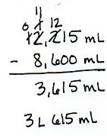
Label each strategy as one of the following:
Problem 1

- Algorithm with mixed units
- Algorithm using smaller units
- Special Strategy, one unit at a time
- Special Strategy, number line
- Special Strategy, counting up

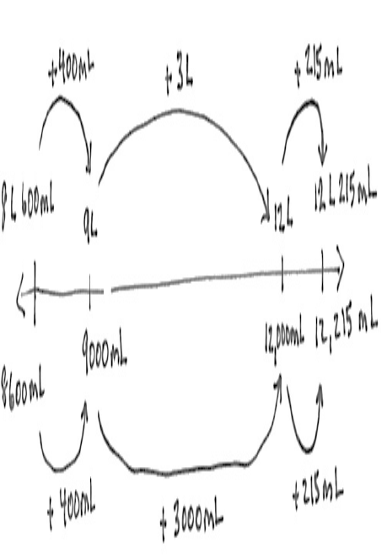
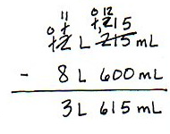
Problem 3
Problem 2

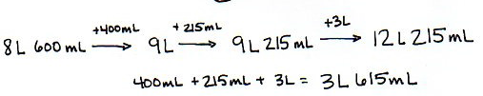
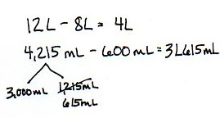
Problem 4
Problem 5

